***273/1***

***Geography***

***Paper 1 2022***

***2 ½ hours***

PAHISCO EXAMINATIONS BOARD

*Uganda Certificate of Education*

GEOGRAPHY

**PAPER 1**

2 Hours 30 Minutes

**Instructions to Candidates**

This paper consists of parts **I** and **II**

Part **I** and section **A** of part **II** are compulsory

Answer only **one** question from section **B** of part **II**

Answers to **all** questions **must** be written in the answer sheets provided

Any additional question(s) answered will **not** be marked

**PART I**

**OBJECTIVE – TYPE QUESTIONS (30 MARKS)**

There are **30** compulsory questions. Each question carries **one** mark.

1. Rapid population growth in Kabale can best be controlled by
2. Sensitization of masses
3. family planning
4. emigration
5. change in land tenure system
6. Which of the following is a metamorphic rock?
7. Marble
8. Obsidian
9. Pumice
10. shale
11. The flood plains of river Thiba are mainly used for the cultivation of
12. rice
13. sugarcane
14. flowers
15. yams
16. Which of the following is a fresh water fish species?
17. Mackerel
18. Tuna
19. Sardines
20. catfish
21. Which of the following process is responsible for the formation of Tarn lakes in East Africa?
22. Faulting
23. warping
24. Glaciation
25. Lava damming
26. Which of the following crops in East Africa grows well in areas with low rainfall?
27. Sisal
28. Cotton
29. Coffee
30. Pyrethrum
31. The major problem facing inland ports in East Africa is
32. Poor vessels
33. Shallow water
34. Theft of goods
35. Insufficient storage area
36. Which of the following industries in East Africa uses scrap as raw materials?
37. Electricals
38. textiles
39. leather tanning
40. steel rolling
41. The speed of chemical weathering in East Africa is mainly influenced by
42. living organisms
43. nature of parent rock
44. nature of climate
45. nature of slope
46. The climate of Lodwar can best be described as
47. hot and humid
48. cold and damp
49. hot and dry
50. warm and wet
51. Which of the following is a non - renewable energy source?
52. Oil
53. Solar
54. geothermal
55. Biomass
56. The decline in cotton production in Uganda is mainly because of
57. Political instability
58. Loss of soil fertility
59. Limited market
60. Changes in climate
61. The most common method used in East Africa for preserving fish for export is
62. salting
63. smoking
64. sun drying
65. freezing
66. The commercial exploitation of Lake Katwe salt mines has mainly been limited by
67. Inadequate capital
68. remoteness
69. limited skilled labour
70. low levels of technology
71. Kidepo valley was gazzetted as a national park mainly in order to
72. utilize marginal land
73. promote tourism
74. discourage nomadism
75. conserve the environment
76. Which the following features in East Africa are a result of wave deposition?
77. Caves
78. blow holes
79. Beaches
80. Cliffs
81. The reduction in Infant mortality rate in East Africa is mainly due to improvement in
82. Sensitization of masses
83. nutrition levels
84. medical facilities
85. security
86. The rangeland areas of Uganda are mainly used for pastoralism due to
87. Presence of savannah grasslands
88. Low population density
89. Remoteness of the areas
90. culture of the people
91. Kenya exports more industrial products than any other country in East Africa mainly because it
92. has more industries
93. is not landlocked
94. has better quality goods
95. is politically stable
96. Revenue from the fishing industry in Uganda has improved mainly because of?
97. importation of modern gear
98. widening of the market
99. increase in fish prices
100. favourable government policy
101. Meanders exist along a river profile due to
102. erosion
103. deposition
104. rejuvenation
105. water logging
106. In which of the following areas does weathering by frost action occur in East Africa?
107. Lake Victoria region
108. Summit of Mt. Kenya
109. North Eastern Kenya
110. Miombo woodlands of Tanzania
111. Butiaba fish landing site is found on which of the following lakes
112. Albert
113. Tanganyika
114. Turkana
115. Victoria
116. The dry conditions experienced in North Eastern Kenya are mainly due to the influence of the
117. North West trade winds
118. North East trade winds
119. South East trade winds
120. South West trade wind
121. The river found along the Tanzania – Mozambique border is
122. Kilombero
123. Pangani
124. Ruvuma
125. Rufigi
126. The proposed construction of an oil refinery in the Albertine region of Uganda is mainly due to the presence of
127. abundant water
128. adequate capital
129. raw materials
130. vast land
131. Landslides along the slopes of Mount Elgon are mainly caused by
132. Crop Cultivation
133. Heavy rainfall
134. Earth quakes
135. Stone quarrying
136. Which of the following has limited the use of air transport within East Africa
137. shortage of aircrafts
138. few airports and aerodromes
139. high transport fares
140. competition from road transport
141. The type of soil erosion commonly experienced in the Kigezi highlans is
142. gulley
143. sheet
144. rill
145. deflation
146. Market gardening is fast developing in East Africa mainly due to
147. rapid population growth
148. rapid modernization of agriculture
149. wide use of fertilizers
150. rapid urbanization

**SECTION A**

1. **COMPULSORY QUESTION: MAPWORK (20 MARKS**)

Answer **all** parts of this question.

Study the map extract 1:50,000 **(UGANDA) ALOI** and answer the questions that follow

1. (i) State the grid reference of the Borehole at Aloi Trading Centre (01 mark)

(ii) Identify the man-made features at grid reference 148506 (02 marks)

(iii) Measure and state (in kilometers) the distance covered by the railway line (01 mark)

1. Identify the economic activities taking place in the area shown on the map extract (05marks)
2. Draw a cross section of the area from Eastings 10 to 18, along northing 56. On it mark and name the:
3. County boundary
4. Hill
5. Rivers Kai and Aloi
6. Loose surface road (07 marks)

(d) Explain the problems faced by the people living in the area shown on the map extract (04 marks)

2. **PHOTOGRAPH INTERPRETATION (COMPULSORY) (15 MARKS)**

Answer **all** parts of this question

Study the photograph provided and answer questions that follow:

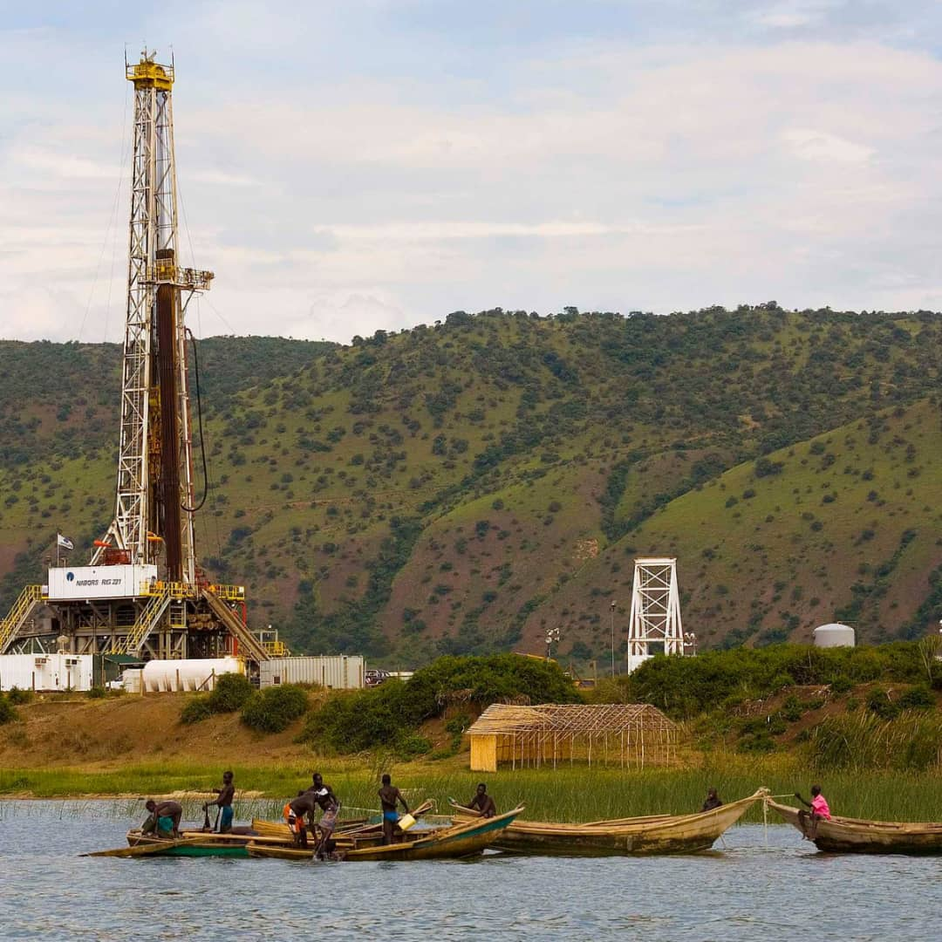

1. Identify the type of photograph shown above (01 mark)
2. Identify the economic activities in the
3. Left middle ground
4. Fore ground (02mks)
5. Describe the factors which have favoured the economic activity in the left middle ground. (05 marks)
6. Giving evidence from the photograph, explain the problems facing the people living around as shown in the photograph (05 marks)
7. Giving reasons for your answer, suggest **one** area in East Africa where the photograph could have been taken (02 marks)

**3. COMPULSORY FIELDWORK QUESTION *(15 MARKS)***

*Answer* ***all*** *parts of this question.*

For any one fieldwork study you have conducted;

a) State the:

(i) topic ***(02 marks)***

(ii) objectives of the study. ***(02 marks)***

b) Draw a cross-section of the area studied and on it, mark and name the;

(i) physical features

(ii) man-made features

***(05 marks)***

c) Explain the relationship between relief and land use types in the area studied.

***(03 marks)***

d) Mention the follow-up activities that you carried out after the field study. ***(03 marks)***

**SECTION B: EAST AFRICA**

Attempt ***only one*** Question from this section. Each question carries ***20 marks***

4. Study the map of East Africa provided and answer the questions that follow

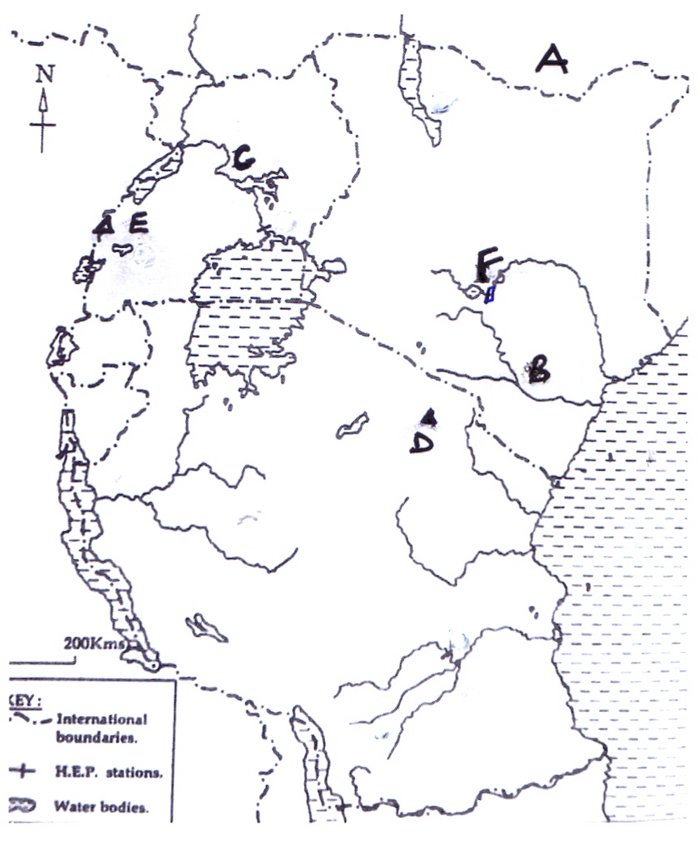

Name the:

(i) Country marked A

(ii) Rivers marked B and C

1. Mountains D and E
2. Waterfall F (06 marks)

(b) Describe the processes that led to formation of the waterfalls in East Africa (04 marks)

(c) State the:

(i) advantages and

(ii) disadvantages of waterfalls (04 marks)

(d) Outline the problems faced in the utilization of rivers East Africa (06 marks)

5. Study table 1; below showing the average annual fresh water fish catch in East Africa between 1993 and 1995 and answer the questions that follow

***Table 1:*** showing the average annual fresh water fish catch in East Africa between 1993 and 1995

|  |  |
| --- | --- |
| **Country** | **Annual fresh water fish catch (in tonnes)** |
| Kenya | 86,000 |
| Tanzania | 100,100 |
| Uganda | 117,600 |
| **Total** | **303,700** |

1. Draw a line graph to show the average annual fresh water fish catch in East Africa between 1993 and 1995 (05 marks)
2. (i) Name the country with the highest annual fresh water fish catch in East Africa (01 mark)

(ii) Describe the factors which have favoured fishing in the country named in (b) (i) above (05 marks)

1. Explain the problems faced by the fishing industry in East Africa (05 marks)
2. Outline the measures being taken to promote fishing in East Africa

(04 marks)

6. (a) Distinguish between coastal erosion landforms and coastal deposition landforms (04 marks)

(b) Explain the formation of any five coastal erosion landforms in East Africa.

(10 marks)

(c) Explain the importance of coastal landforms to the economy of East Africa. (06 marks)

7. (a) Draw a sketch map of East Africa; and on it mark and name:

(i) The Equator (01 marks)

(ii) Urban centers: Nairobi, Tabora and Mtwara (03 marks)

(iii) Natural forests: Mabira and Bugoma (02 marks)

(b) Describe the characteristics of urban centers in East Africa (04 marks)

(c)Explain the problems resulting from rapid urbanization in East Africa (05 marks)

(d)Outline the steps being taken to improve the quality of life in urban areas in East Africa (05 marks)